**AMRITA VIDYALAYAM**

**TRICHY**

**Managed by**: MATA AMRITANANDAMAYI MATH



DEPARTMENT

OF

COMPUTER SCIENCE

PROJECT FILE

2021-2022

Topic: **Student Marks Application**

**AMRITA VIDYALAYAM**

**TRICHY**

**Managed by**: MATA AMRITANANDAMAYI MATH





This is to certify that Master **Arjun G., Ashwin Balaji S., Aravind Chokalingham M.** of Class **XII** Section **B** Register No: **20666445, 20666446, 20666444** have completed their investigatory project in the subject of **Computer Science** as required according to the Central Board of Secondary Education for the academic session **2021-2022**.

**Date: Teacher in charge**

**Examiner’s Signature Principal**

**ACKNOWLEDGEMENT**

I would like to convey my thanks to my **Computer Science** Teacher **V. Nithya** Amrita Vidyalayam, Trichy for her immense help and guidance in the completion of my project.

I would also like to convey my thanks to our Principal **Mrs. Usha Raghavan** and our school management for providing the necessary materials.

I would like to extend my gratitude to everyone who helped me to complete this project.

Name of the Students: **Arjun G., Ashwin Balaji S., Aravind Chokalingham M.**

Register Nos: **20666445, 20666446, 20666444**

Table of Contents

Aim 5

Requirements 5

Sample Tables 6

Bibliography 8

# Aim

We are going to create a web application where teachers can enter the raw marks of the students and that will be stored in a cloud database. Additional information such as Rank, Percentage, Average, Grade, etc. will also be calculated and stored in the database. Teachers can access it whenever needed.

We are going to host the database on a cloud platform. We are using MySQL for managing the database. We are going to utilize a popular web framework called Django. It is a Python-based free and open-source web framework. We are also using GitHub for managing the project files and Visual Studio Code as the Code Editor.

This project aims to provide this useful, elegant-looking web application that could be used by teachers intuitively and simply.

# Requirements

* Django web framework installed for Python using pip installer
* Git client application
* Heroku account and app
* Visual Studio Code
* MySQL Server and Python

# Sample Tables

1. **General information of students (gen_info)**

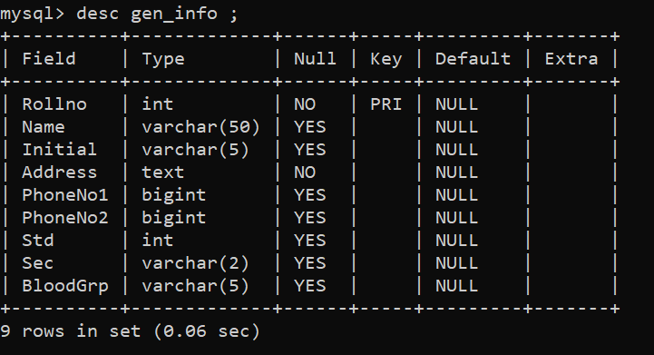

Img. ST_1A

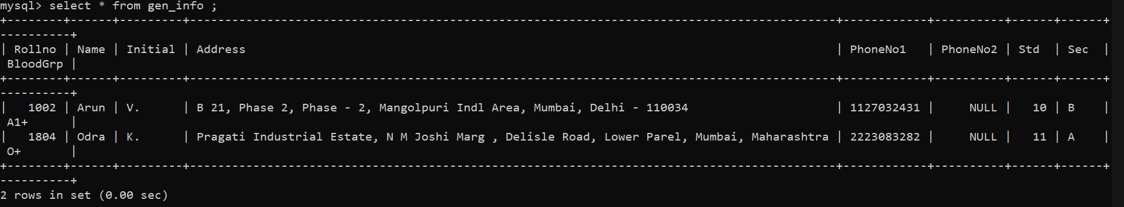

Img. ST_1B

1. **Tests table for Class 10 (tests_class_10)**

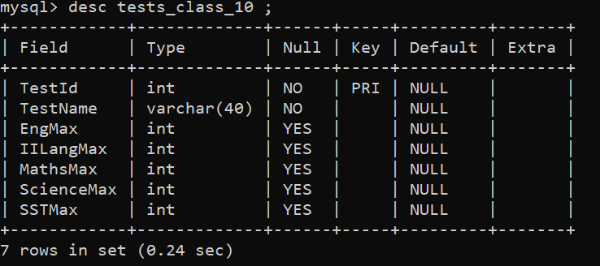

Img. ST_2A

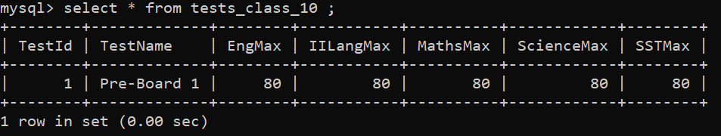

Img. ST_2B

1. **Marks table for Class 10 (class_10)**

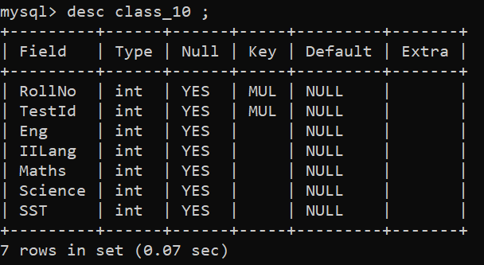

Img. ST_3A

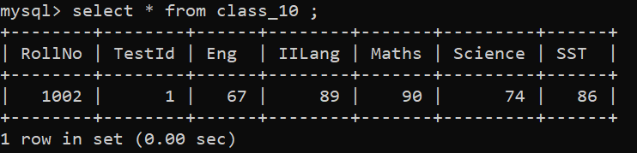

Img. ST_3B

1. **Further information on the tables:**
   1. Tables 1 and 2 can be considered as the primary tables. They have columns **RollNo** and **TestId** as Primary Keys.
   2. In Table 3, columns **RollNo** and **TestId** are Foreign Keys. They have references to the **RollNo** column in Table 1 and **TestId** column in Table 2 respectively.
   3. This demonstrates the concept of a *Relational Database*.

# Bibliography

1. **MySQL Tutorial** - https://bit.ly/3qBA8yp
2. **YouTube Videos List** - https://bit.ly/3Fd7gk8